**IPV6 STATIC ROUTING**

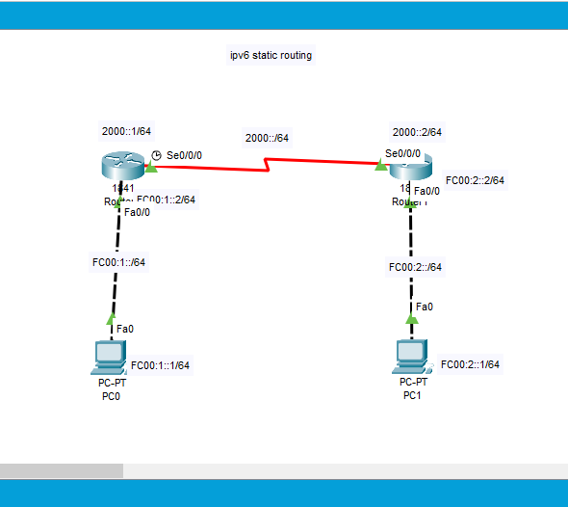

**Enable the routing by following cmd:**

**r0(conf)**[**#ipv6**](https://www.facebook.com/hashtag/ipv6?__eep__=6&__cft__%5b0%5d=AZUVZ0Bg1wAfvNLqplxIqb9nEIKhqNl9aJBK8eM8lNcR3RiPOTK6aLqOFEJ6Prwvxw_R1zhtSREmapGOIufCtjJju47YXpNzSy-P8kuPc-_OOLZ8RH0TshpAOumkj5nOMO-73d0Uz39cthqmIcMV8dud8d7PFsURozyDPyT7CtiUf7LFGac4iuFI7OFij5mv0ZA&__tn__=*N-UK-R) **unicast-routing**

**r1(conf)**[**#ipv6**](https://www.facebook.com/hashtag/ipv6?__eep__=6&__cft__%5b0%5d=AZUVZ0Bg1wAfvNLqplxIqb9nEIKhqNl9aJBK8eM8lNcR3RiPOTK6aLqOFEJ6Prwvxw_R1zhtSREmapGOIufCtjJju47YXpNzSy-P8kuPc-_OOLZ8RH0TshpAOumkj5nOMO-73d0Uz39cthqmIcMV8dud8d7PFsURozyDPyT7CtiUf7LFGac4iuFI7OFij5mv0ZA&__tn__=*N-UK-R) **unicast-routing**

**r0(config)**[**#pv6**](https://www.facebook.com/hashtag/pv6?__eep__=6&__cft__%5b0%5d=AZUVZ0Bg1wAfvNLqplxIqb9nEIKhqNl9aJBK8eM8lNcR3RiPOTK6aLqOFEJ6Prwvxw_R1zhtSREmapGOIufCtjJju47YXpNzSy-P8kuPc-_OOLZ8RH0TshpAOumkj5nOMO-73d0Uz39cthqmIcMV8dud8d7PFsURozyDPyT7CtiUf7LFGac4iuFI7OFij5mv0ZA&__tn__=*N-UK-R) **route fc00:2::/64 2000::2**

**The network address which is to be known by the router 0 and the next hop address of that network (i.e interface ip se0/0/0 of router 1).**

**r1(config)**[**#ipv6**](https://www.facebook.com/hashtag/ipv6?__eep__=6&__cft__%5b0%5d=AZUVZ0Bg1wAfvNLqplxIqb9nEIKhqNl9aJBK8eM8lNcR3RiPOTK6aLqOFEJ6Prwvxw_R1zhtSREmapGOIufCtjJju47YXpNzSy-P8kuPc-_OOLZ8RH0TshpAOumkj5nOMO-73d0Uz39cthqmIcMV8dud8d7PFsURozyDPyT7CtiUf7LFGac4iuFI7OFij5mv0ZA&__tn__=*N-UK-R) **route fc00:1::/64 2000::1**

**The network address which is to be known by the router 1 and the next hop address of that network (i.e interface ip se0/0/0 of router 0).**

